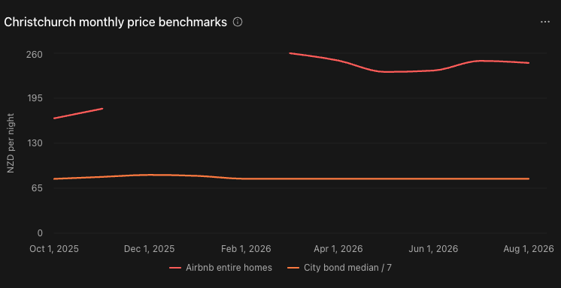
July and August show a small fall in Christchurch Airbnb asking prices while the citywide tenancy median stayed unchanged. Citywide comparisons are available for both months; suburb-level tenancy comparisons remain unavailable.
The main Airbnb group is entire homes/apartments with minimum stays of 1–30 nights, across Christchurch City, including Banks Peninsula.
July versus August
The Airbnb median fell from NZ$249/night to NZ$246/night, a decrease of NZ$3, or 1.2%. The official citywide tenancy median was NZ$550/week in both months, equivalent to NZ$78.57/night.
Consequently, the difference between the two citywide medians fell from NZ$170.43/night in July to NZ$167.43/night in August. Airbnb asking prices were approximately 3.17 and 3.13 times the tenancy nightly equivalent.
These are comparisons between different properties and accommodation products. They do not measure Airbnb profit: occupancy, operating costs, booking fees, property size and quality are not controlled.
The medians use 2,496 observed prices in July and 2,512 in August, approximately 91% of the selected listings. Listing counts increased slightly, from 2,745 to 2,769. Because the listing mix can change, the 1.2% fall does not establish that the same properties reduced their prices, or that the change is statistically significant.
How to interpret the nine figures
Figure | What it shows and the main finding
01 — Monthly price benchmarks | Airbnb prices vary more than the citywide tenancy benchmark. March’s NZ$260 is the highest observed entire-home median; missing summer prices prevent calling it the period’s true peak.
02 — Listing counts | All-room Airbnb listings increased from 2,991 in October to 3,513 in August—about 17.5%. These are snapshot counts, not additional unique properties each month.
03–04 — Area gaps and prices | These use June, the latest usable suburb comparison. Christchurch Central’s entire-home median was NZ$253/night, versus an area tenancy equivalent of NZ$76.71/night. Extreme rankings need caution: Wigram North’s largest eligible gap relied on only five observed prices.
05 — Coverage | Separates geographic assignment, Airbnb price availability, suburb tenancy matches and citywide monthly rent availability. Missing coverage does not mean zero rent or zero properties.
06–07 — Spatial gaps and bars | Show June’s variation between SA2 areas. Grey areas lack sufficient comparison data. Bar height represents price, not building height; approximate Airbnb coordinates introduce boundary uncertainty.
08 — Airbnb and active bonds | Compares market scale. Active bonds indicate long-term rental stock; Airbnb listings indicate listed accommodation. Neither measures advertised vacancies.
09 — July/August comparison | Presents the supported citywide comparison without assigning the city rent to individual suburbs.
How the missing months affect the conclusions
There are two separate limitations:
- December–February: Airbnb prices are absent from the summary, detailed and checked calendar files. Listing counts and geographic analysis remain usable, but Airbnb medians and price gaps cannot be calculated. We cannot reliably describe summer seasonality or calculate a complete-period price average.
- July–August: Airbnb prices and monthly citywide tenancy medians are available, but the retrieved suburb tenancy release lacks the corresponding quarter. Therefore, citywide comparisons work while suburb rents, local gaps and local gap rankings remain blank.
Overall, eight of the eleven months support citywide price comparisons, and six support matched suburb price-gap comparisons. The strongest findings concern observed asking-price differences, listing growth and spatial variation; the data do not establish that Airbnb caused Christchurch’s long-term rents to change.

